Central District Girls Softball 2024 ASAP
Little league – District 13
https://clubs.bluesombrero.com/cdgs
League ID 292399
Chartered 2014

1. Safety Officer

The League Safety Officer is an Officer of CDGS, Elected by the League.
Eugene Martin Firefighter/Paramedic, 224-629-7488 safetyofficer@cdgs301

The responsibilities of the League Safety Officer include (but are not limited to):
- Coordinate all operations of the League Safety Awareness Program (ASAP).
- Ensure all teams have access to safe playing conditions.
- Ensure compliance of required safety trainings
- Maintain safety equipment (first aid kits and AED’s)
- Track injuries and assist in the completion of required paperwork.
- Maintain consistent and open communication with all stakeholders to provide safe playing conditions and report recommendations to board president and Little League District 13.

2. Safety Plan Distribution

The CDGS safety plan is completed by the Safety Officer, reviewed by the Board.
The Safety Officer is responsible for submitting the safety plan to Little League International through the Data Center.
A copy of the CDGS safety plan is published on our website andan electronic copy is distributed to League volunteers. A Physical copy will also be maintained in the Snack Shack.

3. Emergency Plan

In the event of an emergency please call 911. Address of the fields is 5N720 Il Rt 47, Maple Park, IL 60151.

Following the emergency activation please call the President or Vice President and inform them of the situation.
Additionally, if there is an injury, requiring transport by ambulance please notify the Safety Officer.

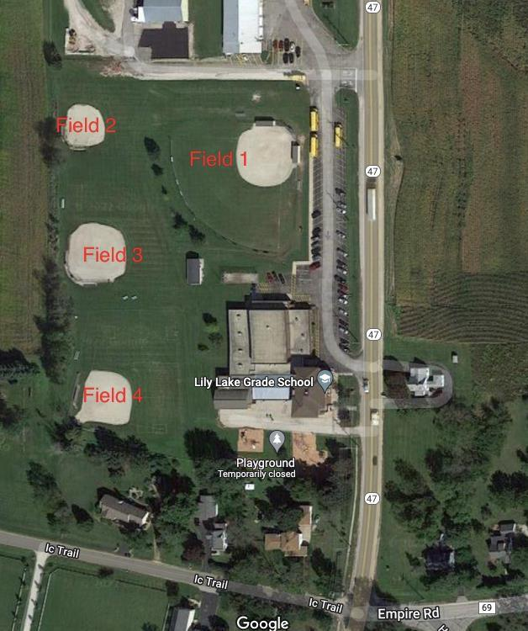

Christina Moses | League President | President@cdgs301.com | 630-209-9328
Julie West | Vice president | VicePresident@cdgs301.com | 847-489-2503
Travis Parry | Treasurer | treasurer@cdgs301.com | 312-203-0683
Tanya Hernandez | Secretary | secretary@cdgs301.com | 847-691-2450
Eugene Martin | Safety Officer | Safetyofficer@cdgs301.com | 224-629-7488
Seth Ridner | Coach Coordinator | sdrinder@yahoo.com | 847-345-9662
Chuck Sanders | Player Agent | playeragent@cdgs301.com | 773-412-0544
Eric Vargas | Webmaster | Ericvarg2515@gmail.com | 847-363-5261
Travis Parry | Umpire Coordinator | tparry@cbbel.com | 312-203-0683
Katie Murphy | Sponsor coordinator | katiecasemurphy@gmail.com | 224-361-6446
Matt Moses | Equipment Mgr. | equipmentmanager@cdgs301.com | 630-903-1826
Mandy Rodiek | Concessions Mgr. | concessionsmanager@cdgs301.com | 773-899-1278
Dayna Vargas | Uniform Mgr. | uniformmanager@cdgs301.com | 847-609-9965

4. Volunteer Application and Background Checks

Little League International requires all league administrators, coaches, and volunteers to complete the Little League Volunteer Application annually. This form is part of the background check administered by J.D. Palatine, Little League’s official background check provider. Anyone refusing to fill out the Volunteer Application is ineligible to be a league member.
CDGS will utilize JDP for our background checks. All paperwork will be completed online.

5. Fundamentals Training

CDGS will hold a Coaches meeting on 3/19. Required trainings will be covered. Training will include but not limited to:
- CDGS Specific Coaching instruction (Hitting, sliding, fielding, pitching)
- Basic first aid training, AED use and policy review
- Field setup/takedown (QR Code)
- Mower and bunker rake training (QR code)
- Snack Shack training links (QR codes)

CDGS has additional training for coaches on the website. Additionally, Coaches shall follow the Coaches Code of Conduct which will be distributed and signed.

6. First Aid Training

CDGS will hold a Coaches meeting on 3/19. Required trainings will be covered. Training will include but not limited to:
- Review of required trainings:
  - Online Concussion Training, through CDC Heads Up
  - Sudden Cardiac Arrest (SCA) Prevention Training, via Eric Paredes Save a Life Foundation
  - Child Protection Program Training (through SafeSport OR USA Baseball): "Abuse Awareness for Adults," see instructions to access this training through USA Baseball below:
    - Sign into your account at USABDevelops.com. Hover over the Education tab, select "Course Catalog."
    - This should take you to https://usamobilecoach.com/courses; sign in again (you will only do this once).
    - From here, you may take any course.
    - To access certificates, log in to USABMobileCoach.com and select your name in top right corner.
    - Click "My Courses" and select "Courses" option.
  - Little League Diamond Leader training: there is currently one course available (supplement courses are being developed). Access the training at https://www.littleleague.org/diamondleader/. Either create a new account or login to complete the training (blue buttons after 2nd paragraph on the page).
  - First aid kit training
  - AED training use and Policy review
  - CPR /AED training. Free online. National CPR Foundation

7. Field Evaluations (pre-game) and field days

Prior to all practices and games, a coach or designee shall inspect the area of play for any safety concerns. If any problems are found, an attempt to make the field safe shall be attempted. In the event the problem cannot be fixed, notification shall be made to the field’s coordinator and the safety officer. Play shall be halted on the field until proper repairs can be made.

Field days are scheduled for 3/23/24, 4/6/24 and 4/7/24. General maintenance, as well as resetting of all bases, new home plates, rebuilding the clay foundations of the batters’ boxes and pitchers mounds to be accomplished.

8. Annual Facility Survey

The annual Little League Facility Survey is to be completed and submitted with the ASAP plan. This is an online form that serves to review the fields and facility each year and assists in making goals for improvements as needed. This is available in the Little League Data Center.

9. Concessions Safety
CDGS will operate a Concession Stand, known as the “Snack Shack” No raw foods will be sold. CDGS plans to partner with local vendors to sell hot foods on special occasions.
CDGS will follow the Concession stand Safety Tips, from LittleLeague.com https://www.littleleague.org/university/articles/concession-stand-safety-tips-12-steps-to-safe-sanitary-food-service/

10. Equipment
CDGS will utilize an Equipment manager to budget, inspect, coordinate repair, distribute and collect equipment. Catchers’ equipment will be distributed to each team. Players are encouraged to have their own helmet. In the event they cannot provide one, CDGS will attempt to provide one. CDGS strongly recommends that all players wear a facemask while in the field of play.
Inspection of equipment will be the Coaches and Umpires responsibility. Bats shall be checked for the 1.20 BPF and the USSSA stickers. Any noted cracks or deformities the bat shall be removed from play.

11. Accident Reporting
In the event of an injury, seek appropriate care as needed. Once care has been received, please inform the safety officer of the injury. Through little league, there is supplemental accident insurance. The form and instructions are linked. Please complete this and return to the safety officer in 24-48 hours. Additionally, please complete a injury tracking form and return.

12. First aid kits
Each team will be provided with a first aid kit. These will come stocked at the beginning of each season. There are extra supplies in the snack shack, as well as another first aid kit and AED. If you need more supplies, please contact the Safety Officer.
- To include but not limited to: Gloves, CPR mask, scissors, tweezers, biohazard bags, various bandages, gauze, tape, antiseptic cleaner.
CDGS has a SkyScan lightning detector for use during potentially hazardous weather. It shall be the responsibility of the worker in the snack shack to monitor. If there are no snack shack workers, a coach or manager shall be responsible.
CDGS has three AED for use as needed. Signs have been placed on two fixed locations. One in the snack shack, and one in the shed of Field 1. One AED is for use if needed at remote facilities that do not have one.

13. Enforcement of Little League Rules
CDGS is committed to enforcing Little League rules. It is strongly recommended that all coaches, assistant coaches and board members have the rulebook app on their phone.
Little league rules shall be enforced at practice as well as games.
CDGS utilizes dis-engageable bases on all fields.

14. Player/Coach Data
CDGS will submit player registration data, roster data, and coach and manager data in the Little League Data Center.

15. Answer New Survey questions.
- Unable to find updated questions for 2024

